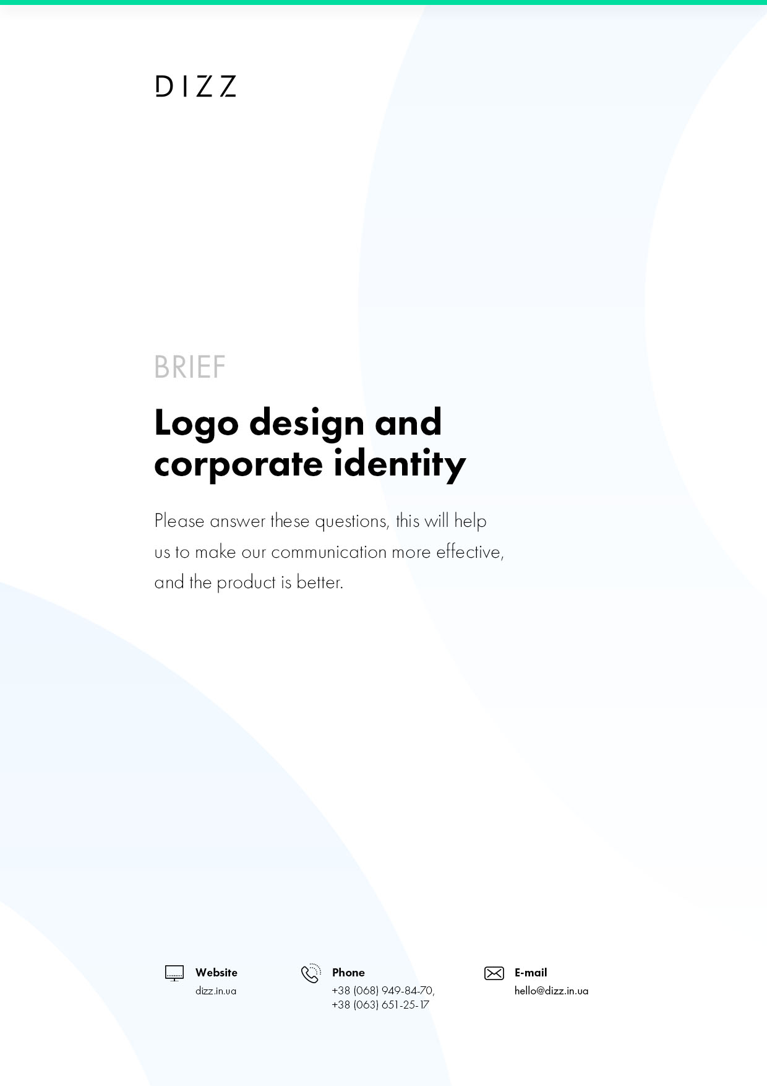

This brief will help us prepare for the job to do it in the best way possible for you. How clearly and exhaustively you answer questions depends on how quickly you and I will start speaking the same language to solve the problems as quickly and efficiently as possible.
We guarantee you the complete confidentiality of the information provided to us.
Brief is not a technical task and only helps us understand how you see your future corporate identity.
If any of the questionnaires seem difficult to you, please contact us for clarification. If you have your own brief - provide it instead of this, the missing information we will clarify at the meeting.

FOR WHAT?
  - Why do you need a logo and/or corporate style?
What are the challenges that development should solve?
Describe the tasks of the logo:
  - Contact points and media. Where will your logo/brand style be most often seen by the consumer?
Describe where the logo is planned:
  - What does the consumer feel about visual design?
What image and character of the brand should be formed?
Describe the sensations:
  - By what criteria will the effectiveness of the development be evaluated?
Describe the criteria:

FORMA AND CONTENT
  - Language versions
Choose one or more options ( ◌ Just click on the point.)
◌ Ukrainian
◌ Russian
◌ English
◌ Other language
  - Name
Write a name for each language version
  - What visual images reflect the essence of your brand?
Describe the images:
  - What images and solutions do you think are unacceptable to use and why?
Describe unacceptable images:
  - What character of the logo and style, in your opinion, is preferable to creating the desired image of the brand
(discreet, expressive, romantic, masculine, strong-willed, etc.)
Describe the images:
  - What type of logo do you think is preferable to creating the desired brand image?
The next page of the table presents versions of logos. Choose one or more options ( ◌ Just click on the point.)

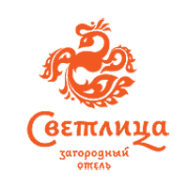 | 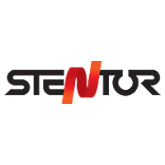 | 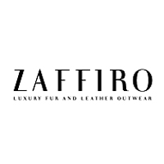 | 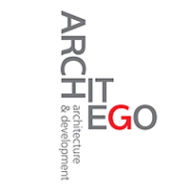
Combined: sign- sign | The sign is included in the title | Font | Compositional font
[ ◌ ] | [ ◌ ] | [ ◌ ] | [ ◌ ]
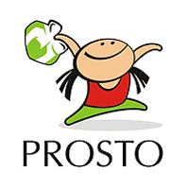 |  | 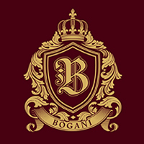 | 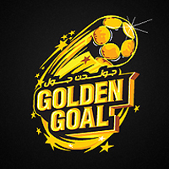
Character | Just a sign | Emblem | Emblem
[ ◌ ] | [ ◌ ] | [ ◌ ] | [ ◌ ]
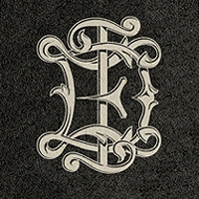 | 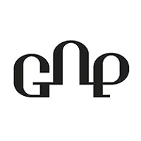 | 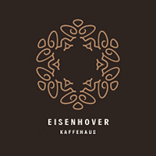 | 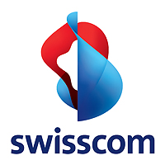
Monogram | Ligature | Ornament | Dynamic - animated by the link::
[ ◌ ] | [ ◌ ] | [ ◌ ] | [ ◌ ]
  - What style/method of graphic logo solution, in your opinion, is preferable to creating the desired image of the brand?
There are variants of logos. Choose one or more options ( ◌ Just click on the point.)
Form and counterform
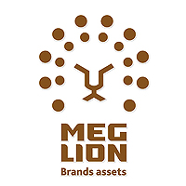 |  |  | 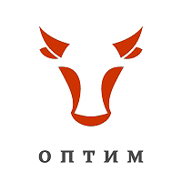
[ ◌ ] | [ ◌ ] | [ ◌ ] | [ ◌ ]
Allegory, metaphor
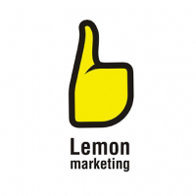 | 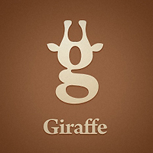 | 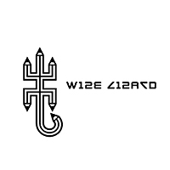 | 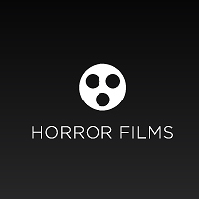
[ ◌ ] | [ ◌ ] | [ ◌ ] | [ ◌ ]
Calligraphy
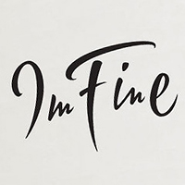 | 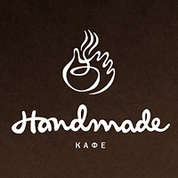 | 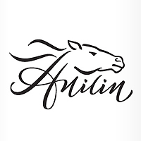 | 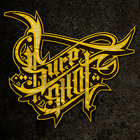
[ ◌ ] | [ ◌ ] | [ ◌ ] | [ ◌ ]
Volume
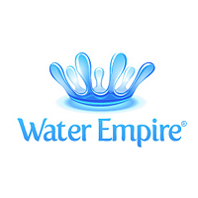 | 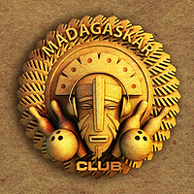 |  | 
[ ◌ ] | [ ◌ ] | [ ◌ ] | [ ◌ ]
Typography
 | 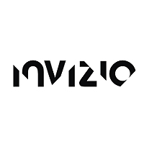 | 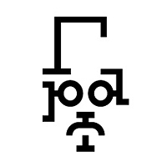 | 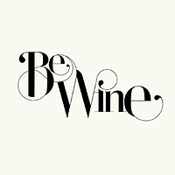
[ ◌ ] | [ ◌ ] | [ ◌ ] | [ ◌ ]
Minimalism, brevity
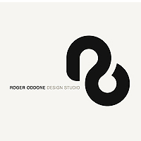 | 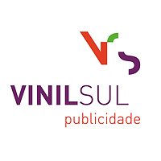 | 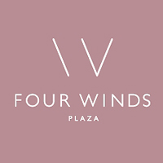 | 
[ ◌ ] | [ ◌ ] | [ ◌ ] | [ ◌ ]
Abstraction
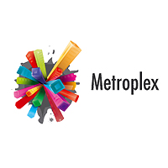 | 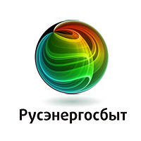 | 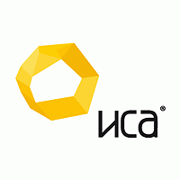
[ ◌ ] | [ ◌ ] | [ ◌ ] | [ ◌ ]
Geometry
 | 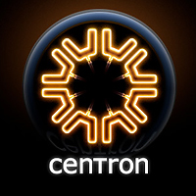 | 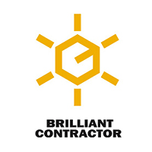 | 
[ ◌ ] | [ ◌ ] | [ ◌ ] | [ ◌ ]
Drawing
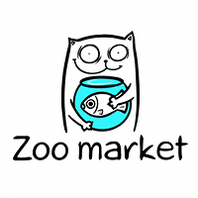 | 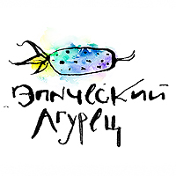 | 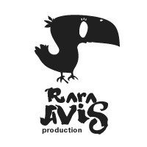 | 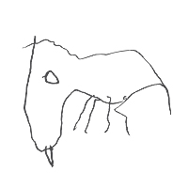
[ ◌ ] | [ ◌ ] | [ ◌ ] | [ ◌ ]
Art
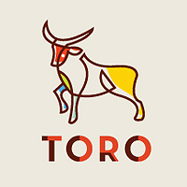 | 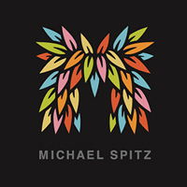 | 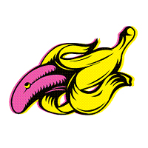 | 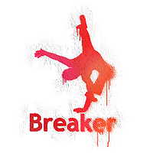
[ ◌ ] | [ ◌ ] | [ ◌ ] | [ ◌ ]
Childhood, intentional infantilism
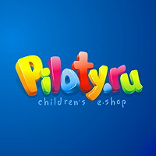 | 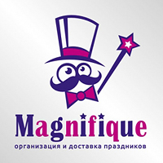 | 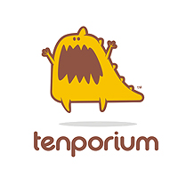 | 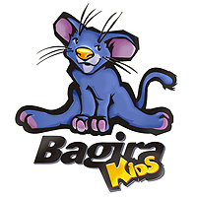
[ ◌ ] | [ ◌ ] | [ ◌ ] | [ ◌ ]
  - What colors (and their number) do you think are preferred to create the desired brand image?
Include preferred colors:
  - Give examples of logos and styles of other brands that you consider successful in terms of creating the desired brand image and explain why?
Include company names or logo links:
  - Give examples of logos and styles of other brands that you think are not successful in terms of creating the desired brand image and explain why?
Include company names or logo links
  - In production, your corporate style should be economical or permissible to use non-standard design solutions?
For example, unusual paper, embossment, cutting, congreve and so on?
Include company names or logo links
  - What branded media should be developed?
Choose one or more options ( ◌ Just click on the point.)
Logo detail
Logo development | Vector- Rastre. 3 options, 3 edits | [ ◌ ]
Logo development | Vector- Rastre. Monochrome adaptation. 5 options, 3 edits | [ ◌ ]
Hydeline | Building principles and guidance and logo recommendations | [ ◌ ]
Corporate style
Brand base | Develop a common style of all elements. Basic color schemes, font selection, branded patterns, modular grids. | [ ◌ ]
A simple business card | Logo and text | [ ◌ ]
Branded business card | Unique design. Branded style. Screen printing seal | [ ◌ ]
Branded form | As part of the corporate style | [ ◌ ]
Branded form q CB | Unique design. Branded style. Screen printing seal. | [ ◌ ]
Document folder | As part of the corporate style, for A4 sheets | [ ◌ ]
Envelope set | As part of the corporate style, C6, E65, C5 | [ ◌ ]
Flyer one-sided | 210x100 mm | [ ◌ ]
Two-way flyer | 210x100 mm | [ ◌ ]
Flyer A4. One side/Two sides | Double or triple folding leaflet is a common | [ ◌ ]
Board 3/6 m. | The template of the billboard within the corporate style. | [ ◌ ]
Board 3/6 m. | Unique layout of the shield | [ ◌ ]
CDdesign/CD cover CD | As part of the corporate style | [ ◌ ]
Email | Mailing template | [ ◌ ]
Package | As part of the corporate style | [ ◌ ]
Bag | As part of the corporate style | [ ◌ ]
Branded sticker | As part of the corporate style | [ ◌ ]
Label, Sticker | As part of the corporate style | [ ◌ ]
Souvenirs | Mug, pen, cap, T-shirt, etc. The price for adapting the corporate style per design unit. | [ ◌ ]
Packaging is simple | Design 2-3 carrying planes, simple shape | [ ◌ ]
Packaging is tricky | Complex shape in 6 or more sides | [ ◌ ]
Packaging with cut pattern | Ready-made packaging template for printing and complex cutting on a plotter | [ ◌ ]
  - What type of corporate style guide do you need?
Choose one or more options ( ◌ Just click on the point.)
◌ Brandbook (marketing strategy description - description of visual communications and standards of work with them on the example of different media)
◌ Guideline (description only of standards and rules of working with the corporate style)
◌ You don't need anything.
  - What else, what will clarify the task of developing the corporate style, we need to know?
Describe more information

