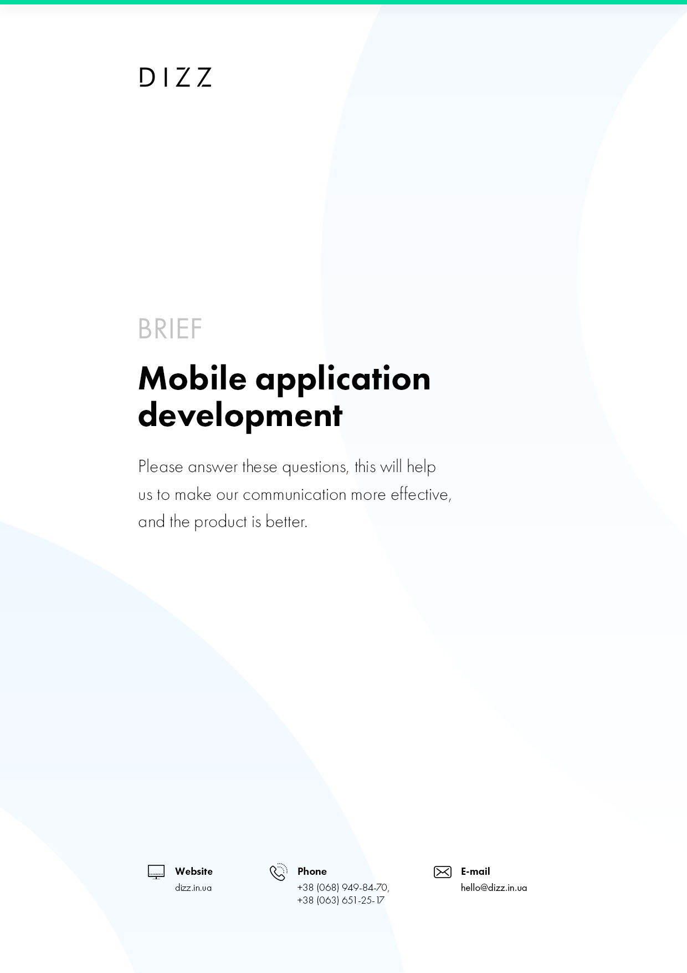

CONTACT DETAILS

YOUR CONTACT:
Company:
Date:
Contact and position:
The scope of the company's activities (for the face of the physical person to indicate the direction)
Phones:
E-mail:
Site:
Other channels (Skype, Telegram, Viber, etc.)

ABOUT NEW MORE
 | - App Type 1
 |  | App types |  | The right thing to do is to mark with an asterisk .
 |  | Business app
 |  | Application for state structures
 |  | Social network
 |  | Learning app
 |  | Gaming app
 |  | Communication
 |  | Reference
 |  | Navigation
 |  | Applied
 |  | Another
 | - App Type 2
 |  | App types |  | The right thing to do is to mark with an asterisk .
 |  | Corporate
 |  | Online store
 |  | Game
 |  | Information
 |  | Learning app
 |  | Another
 | - The main purpose of the mobile app
 |  | Describe the main purpose of your mobile app in this cell. What you want to achieve with it (new sales channel, customer base, automation, etc.)
 | - List the main features of your future app, also here describe the idea of the project (must-fill)
 |  | ...
 | - The main users and their actions in the mobile app. Who, what and why will do in the application. (must-fill)
 |  | ...
 | - Write a pre-application structure: main sections, subsections.. (must-fill)
 |  | ...
 | - Give examples of such applications
 |  | Application |  | Link to The App Store or Google Play
 |  | ... |  | ...
 |  | ... |  | ...
 |  | ... |  | ...
 |  | ... |  | ...
 | - What exactly do you like about these apps?
 |  | ...
 | - What solutions do you not like in these apps?
 |  | ...
 | - For which platforms are planned to be developed (must-be filled)
 |  | App types |  | The right thing to do is to mark with an asterisk .
 |  | iOS (iPhone)
 |  | iOS (iPad)
 |  | Android (smartphone)
 |  | Android (tablet)
 |  | Windows Phone (smartphone)
 |  | Windows Phone (tablet)
 | - What languages are planned in the mobile app? (must-fill)
 |  | Language |  | The right thing to do is to mark with an asterisk .
 |  | English
 |  | Ukrainian
 |  | Russian
 |  | German
 |  | Italian
 |  | French
 |  | Another |  | Write to this cell which languages are required additionally
 | - Do I need to design a mobile app? (must-fill)
 |  | Yes |  | No
 | - Is there a need to create an application management system? (must-fill)
 |  | Yes |  | No
 | - Is the development of a promotional site required? (must-fill)
 |  | Yes |  | No
 | - Who will technically support the app? Do I need maintenance after warranty maintenance of this application? (must-fill)
 |  | Yes |  | No
 |  | ...
 | - The planned budget for the project? (must-fill)
 |  | ...
 | - The desired timeline for the development of the application (must-have)
 |  | ...
 | - Do you have any additional material? For example: TK, BRIEF, hand-sketch. (must-fill)
 |  | Link to materials...
 | - Is there monetization on the project, what will it be? (must-fill)
 |  | ...
 | - Any useful information in the project
 |  | ...

