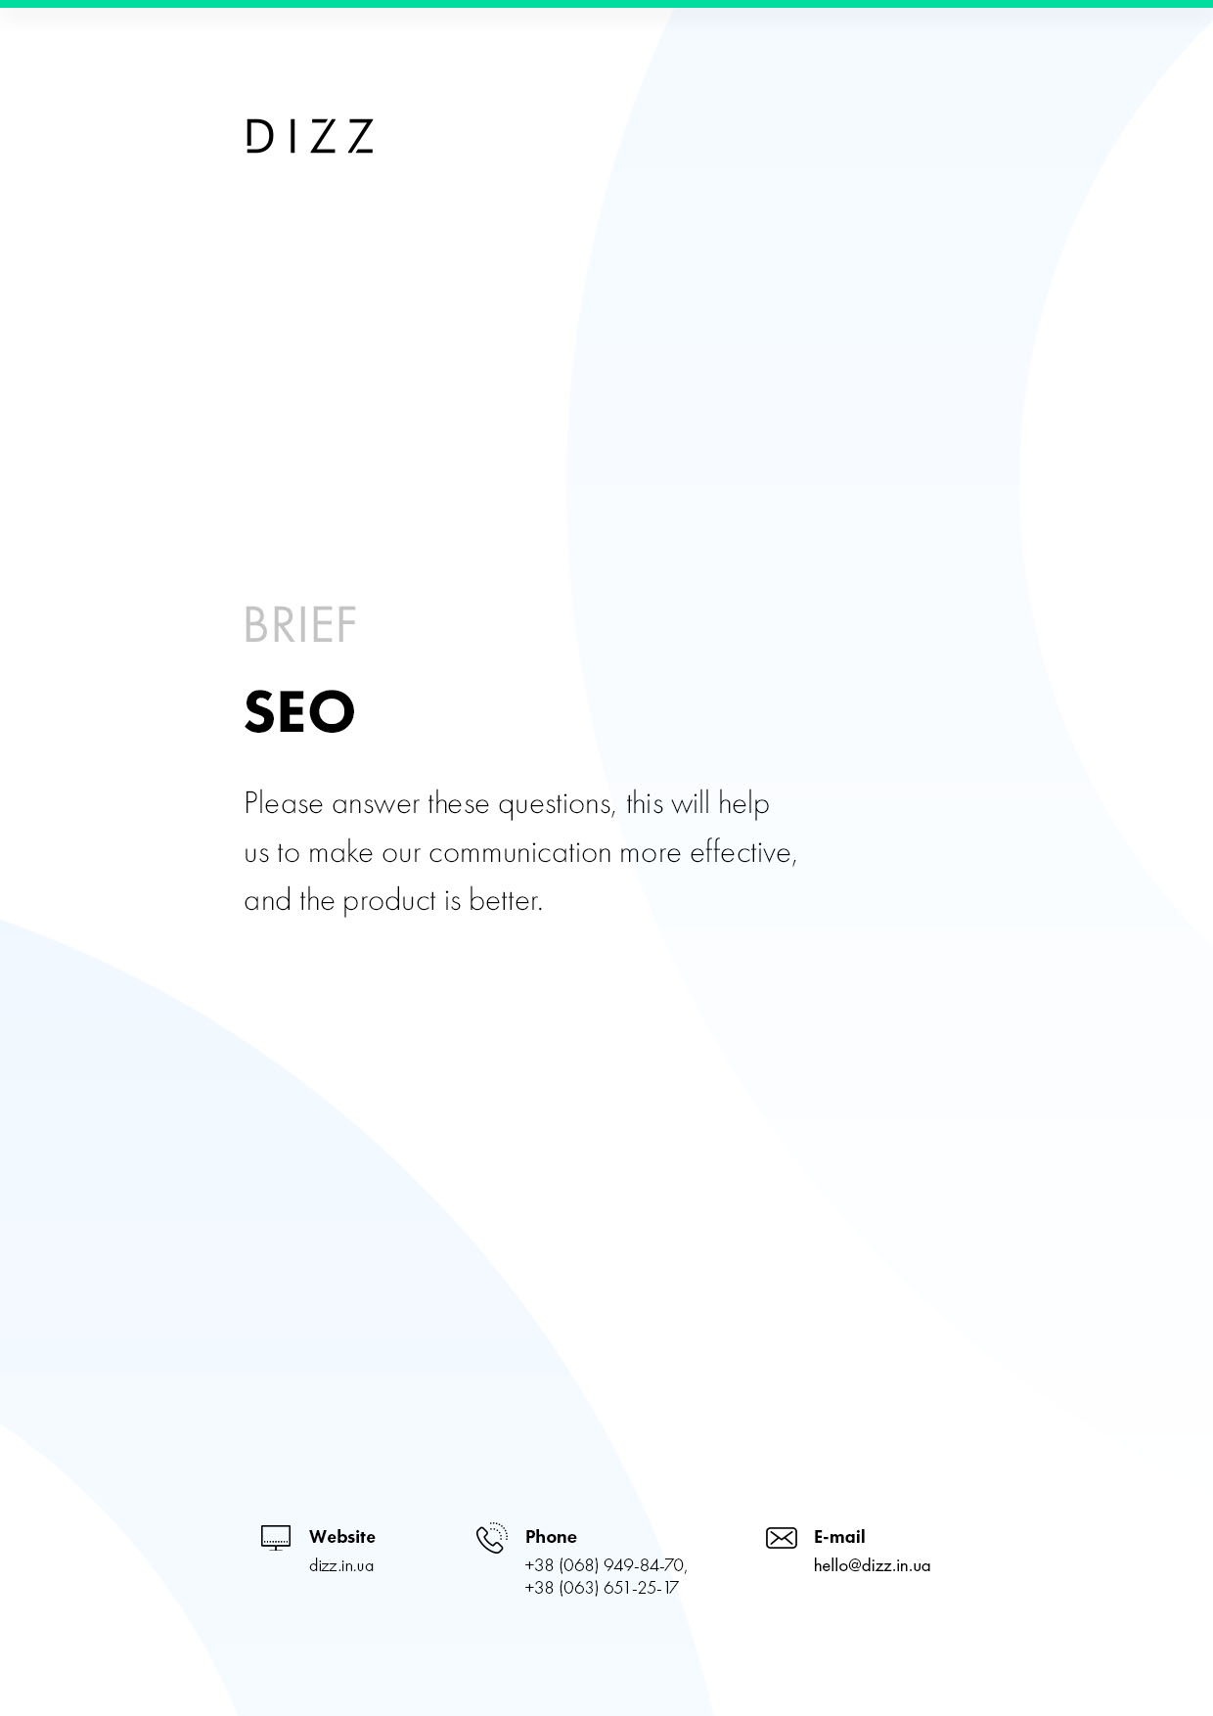
- GENERAL INFORMATION
  - Organization name
What is the name of your organization?
  - Address
What's the address?
  - The scope of the organization
What is your organization's business with
  - Contact
Include phone number, e--mail, skype

- INTERNET SITE

  - Site address
https://...
  - Hosting provider
What's the address?
  - Management system
Point out the control system
  - The life of the site
Set a deadline
  - Site tasks
Include one or more of your site's tasks

3.SEARCH FOR
  - Promotion theme
What of these products/services should be reflected in the promoted requests
  - Searches
Include mandatory requests if there is
  - Tasks to advance
For example, increasing recognition and loyalty to THE TM, increasing resource attendance, occupying the site positions in search engines on certain requests
  - Estimated monthly budget, U.S.
For example, 200-500, 500-1000, 1000-1500, 1500-2500, more than 2500

4.ADDITIONAL INFORMATION
Provide more information to improve your product's understanding

