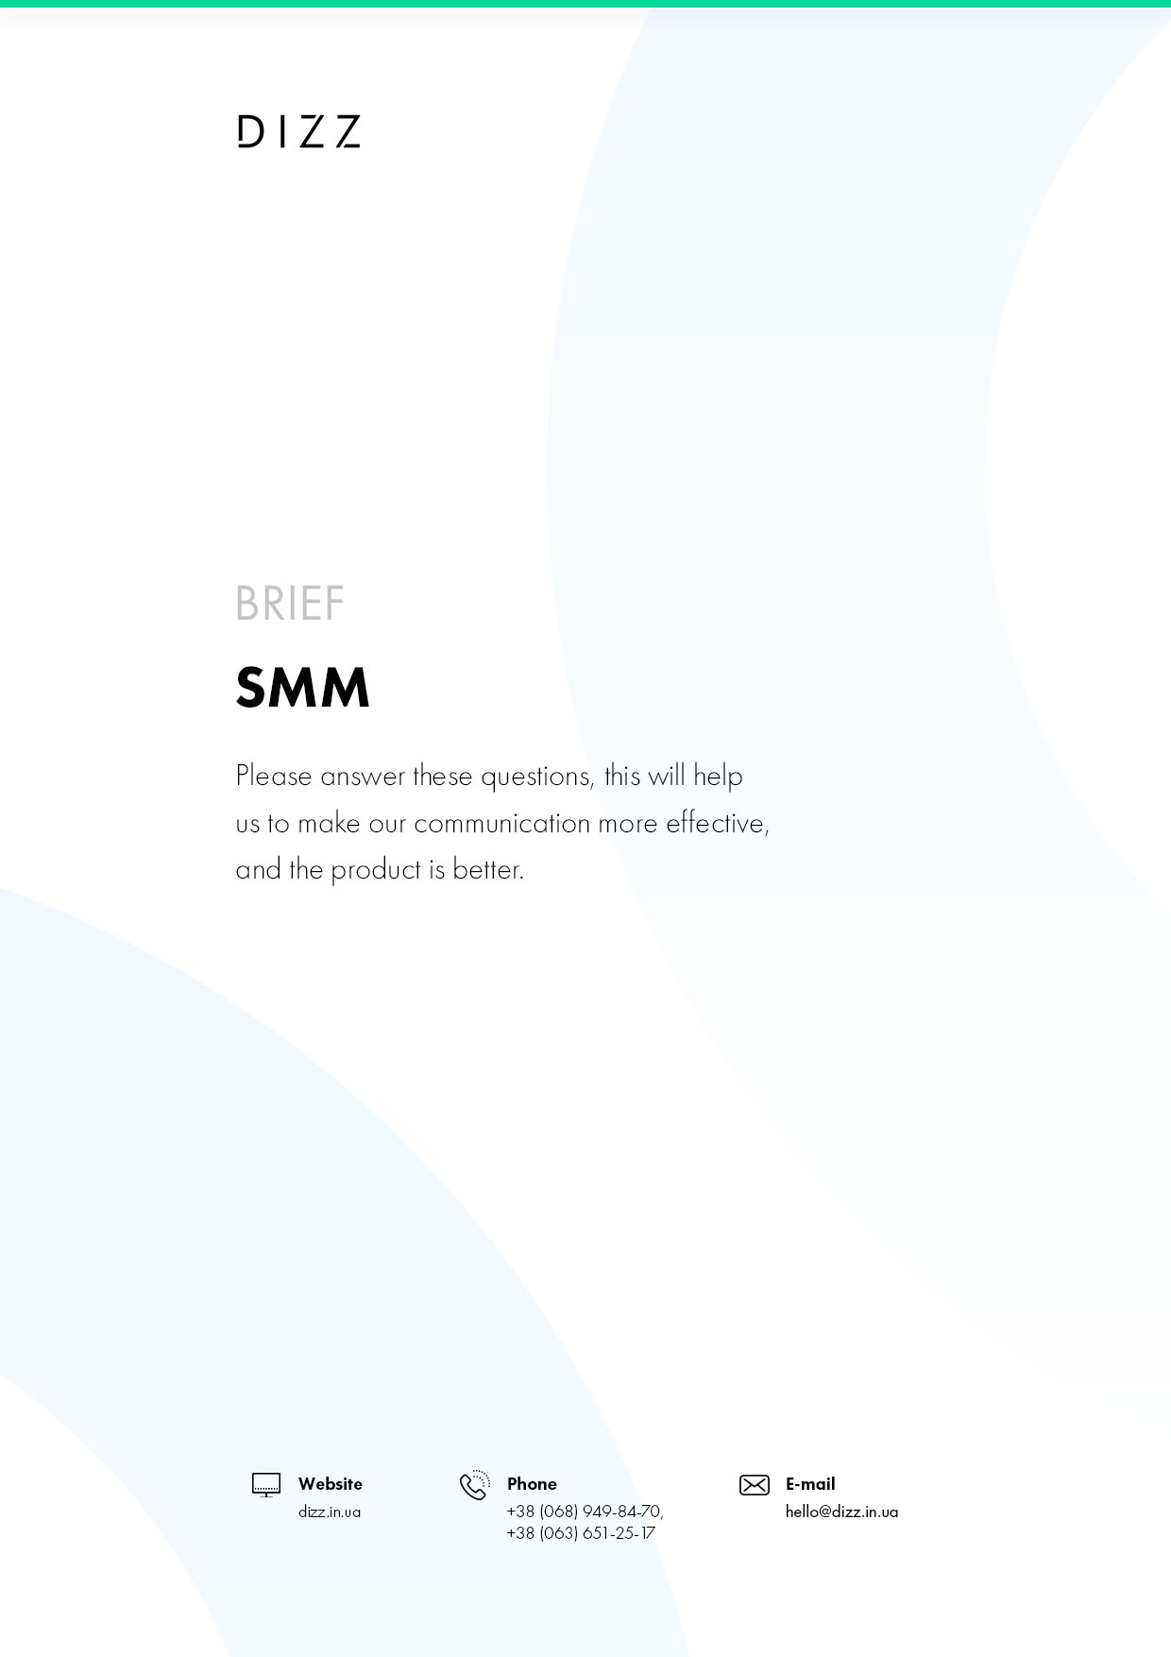

- INFORMATION ABOUT COMPANY
  - Organization name
What is the full name of the organization?
  - Address
What's the address?
  - Scope
What is your organization's business with
  - Responsible
Include phone number, ee-mail, skype,responsible person who can answer questions

- SMM-PROMOTING YOUR COMPANY
  - The goal of promoting social media
For example, "familiarization with a new product," "getting contacts," "site attendance"
  - Do you already have social media posts?
(Facebook, Twitter, Vkontakte, etc.), for example, https://vk.com/dizz_agency
  - Is social media promoting accompanied by other advertising campaigns?
If so, specify which channels are being used
  - Is social media promoting accompanied by other advertising campaigns?
Set a deadline
  - Site tasks
Include one or more of your site's tasks

ADDITIONAL INFORMATION

  - Content
Do you plan to provide content for promotion or writing and photo/video selection on your own?
Choose one option ( ◌ Just click on the point.)
◌ We're going to pick up the content on our own.
◌ No, we need your help.
  - Checking content
Will you check the content prepared for social media
Choose one option ( ◌ Just click on the point.)
◌ We're going to check all the materials.
◌ No, we trust you.
  - Shares
Are you ready to allocate an additional budget for various actions? (The promotions mean discounts, prize draws, discount cards, testing of your products by third parties)
Choose one option ( ◌ Just click on the point.)
◌ Yes, we plan to hold promotions
◌ No, we don't plan
  - What result do you expect from promotion on social networks
For example, the number of registrations on the site, increased sales, more loyal customers, more comments, etc.)

