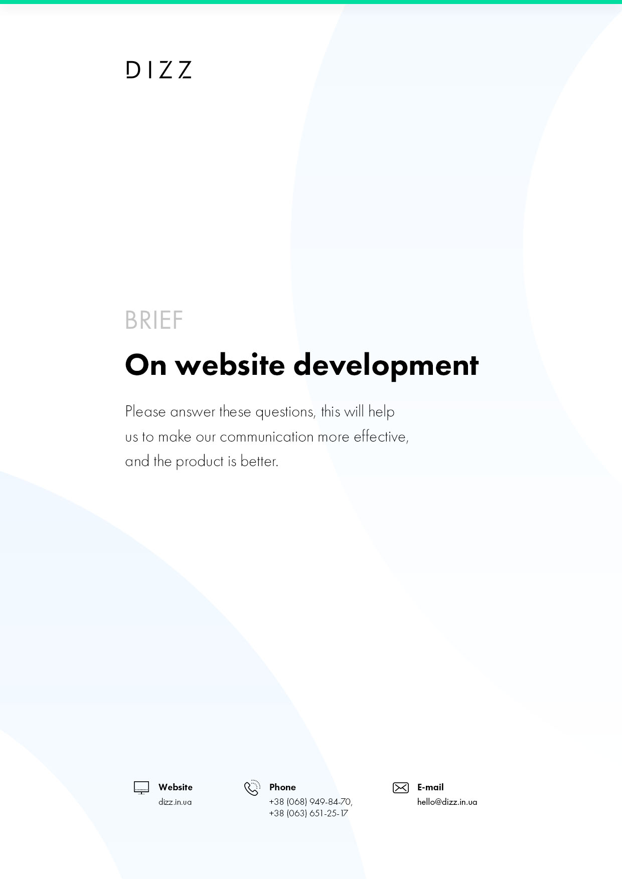

A what?
WHAT IS A PRODUCT?
  - The essence of the brand (the main idea (mission) of the product).
∗Here and further on the brief by "product" means a product, service or company.
Describe the brand:
  - Unique trade offer (UTP) product.
Why exactly will your product (relatively competing) want to buy the consumer?
Product positioning (the main difference from the main competitors).
Describe the uniqueness of your product:
  - 3 core product values (rational and/or emotional)?
Describe the product's values:
  - What is the benefit to the consumer of each of the above values?
Describe the product's values:

WHO'S IT FOR?
Important! Avoid formulaic and therefore useless descriptions! Describe your consumer as a living person, so that your story can clearly represent a particular person and his actions.
  - Which three consumer groups will use your product most often? Who is it designed for?
Describe them in the following parameters or in free form (first of all describe the largest group - the core of the target audience):
- demography: gender, age, marital status, religion, nationality, etc.;
- social imaging: social status, education, occupation, monthly income, etc.;
- Behavior: customer authority, degree of product awareness, degree of interest in the product, degree of commitment to the product, consumption intensity, perception/prejudice stereotypes;
- lifestyle and psychological portrait;
- motivation ratio: rational/emotional.
Group 1. "Enter the name of the group"
What percentage of the total consumption of the product is consumed by this group?
***%
Group 2. "Enter the name of the group"
What percentage of the total consumption of the product is consumed by this group?
***%
Group 3. "Enter the name of the group"
What percentage of the total consumption of the product is consumed by this group?
***%

FOR WHAT?
  - What does the consumer need your product for?
What consumer problems does he solve, what makes his life easier?
Describe your product:
  - When and how will the consumer use your product most often?
Describe your product:
  - Is your product familiar to the consumer?
◌ The product is innovative and the consumer needs to be accustomed to its consumption.
◌ The product is used to, but has improvements relative to competing.
Include these improvements:
◌ The product is no different from the competition, it is the same.
◌Other:
Tell us about the uniqueness of your product:

FOR WHAT?

  - What kind of purchase is your product for the consumer: simple or complex?
Show the consumer's action chain from wanting to buy a product in this category before directly purchasing the product.
Describe the chain of action:
  - In what situation, under what conditions will the consumer most often buy your product?
Consumers of the 1st group.
Describe the 1st consumer group:
Consumers of the 2nd group.
Describe the 2nd consumer group:
Consumers of the 3rd group.
Describe the 3rd consumer group:
  - Price and status characteristics of your product.
Describe the characteristics of your product:
  - Why would the consumer want to pay such a price for the product and what attributes of the product will convince it in this status of your product?
Describe the benefits of your product:

WITH KEM?

  - Describe 3 of your main competitors by the following parameters:
1 competitor.
- Name
- Site
- Competitor's strengths regarding your product/brand
- competitor's weaknesses relative to your product/brand
- positioning and competitor's TPP
- competitor's product/brand values
- how long a competitor has been on the market
- share of % of a competitor's product consumption relative to the entire market volume
2 competitor.
- Name
- Site
- Competitor's strengths regarding your product/brand
- competitor's weaknesses relative to your product/brand
- positioning and competitor's TPP
- competitor's product/brand values
- how long a competitor has been on the market
- share of % of a competitor's product consumption relative to the entire market volume
3 competitor.
- Name
- Site
- Competitor's strengths regarding your product/brand
- competitor's weaknesses relative to your product/brand
- positioning and competitor's TPP
- competitor's product/brand values
- how long a competitor has been on the market
- share of % of a competitor's product consumption relative to the entire market volume
THE SCALE OF INTERESTS

  - Scale of interests:
◌International
◌Federal
◌Regional
◌Local
  - A distribution plan for your product with geographic, time and quantitative metrics.
Describe the plan:
  - What else do you think is important for us to know about the product/brand, so that our work is more effective?
What are your product features:

IMPORTANT QUESTIONS FOR THE PRICE AND TIME:

  - Describe the task briefly. What do you need to do?
Describe the task
  - The address of the current site:
Enter the address
  - What problems of the existing site need to be solved?
Point out the problems
  - Do you need a complete development of the site (design, layout, programming) or only a part (site page design)?
Describe the task
  - Site type:
Mark one of the points
◌ Landing Page
◌Promotional site
◌Website-visit
◌Corporate/Catalogue
◌ Online shopping
◌Portal
  - How would you describe the look of the future website?
Mark one of the points
◌ The European
◌Minimalistic
◌Business
◌Solid
◌Provocative
◌Creative
◌Portal
◌ Strict corporate
  - Do you have a logo/brand style?
Yes, no.
◌Yes
◌No
  - Are there any wishes for the timing?
What is the desired deadline for the project
  - What is the allocated budget (from 20,000 UAH/$1000)?
Enter the amount of $20,000/$1000
  - Describe the proposed structure of the site?
Mark one of the points
◌Home
◌ About us
◌Partners
◌Collaboration
◌Services
◌Catalogue
◌Maintenance
◌News
◌Contacts
  - Describe the site modules:
Mark one of the points
◌Photo/video gallery
◌ The question-answer
◌ Popular articles and news
◌ Subscription newsletter
◌ Social bookmarks
◌ Subscription to news and e-mail mailing - setting up a mailing template based on the site's design
◌ Site search
◌ Payment systems for payment (Private 24 (LigPay), Visa and Master Card)
◌ New Mail Delivery Module
◌ Additional modules (sorting, filtering)
◌"Human-like URL"
  - Language versions:
Mark one of the points
◌Rus
◌Ukr
◌Eng
◌ If others are needed, please specify
  - Do you have any graphic material for the design of the site? (Illustrations, professional photos, etc.)
Describe the material available
  - Will you need to develop a mobile version of the site or adapt to mobile devices (adaptive design and layout)?
Yes, no.
◌Yes
◌No

ADDITIONAL questions THAT MAKE OUR WORK AND MORE PRODUCTIVE:

  - Do you have an employee who will continue to support the site?
Yes, no.
◌Yes
◌No
  - Is the site required or will you do it yourself?
Yes, no.
◌Yes, it's required.
◌No, we're going to fill it ourselves
  - Is there a preference for the site management system you use?
Mark one of the points
◌Wordpress
◌Opencart
◌ Unique CMS (designed to meet your needs)
  - Examples of sites that you like:
Include links to sites you like.
Example 1(https://...)
What exactly do you like about it? (location of objects, colors, structure, etc...)
Example 2(https://...)
What exactly do you like about it? (location of objects, colors, structure, etc...)
Example 3(https://...)
What exactly do you like about it? (location of objects, colors, structure, etc...)
  - Which sites don't like it. Why?
Include links to sites you don't like so we don't make mistakes again.
Example 1(https://...)
What exactly do you not like about this site? (location of objects, colors, structure, etc...)
Example 2(https://...)
What exactly do you not like about this site? (location of objects, colors, structure, etc...)
Example 3(https://...)
What exactly do you not like about this site? (location of objects, colors, structure, etc...)
  - Competitors' websites:
Include links, sites, competitors.
Competitor 1(https://...)
What exactly do you not like about this site? (location of objects, colors, structure, etc...)
Competitor 2(https://...)
What exactly do you not like about this site? (location of objects, colors, structure, etc...)
Competitor 3(https://...)
What exactly do you not like about this site? (location of objects, colors, structure, etc...)
  - How many people in the company decide on this task:
Include the number of people:
  - Are you planning to promote the site (SEO, SMM)?
No, no.
◌ What type of promotion do you need? (added question)
◌No plan
  - What's the best way to contact you?
What's the way to connect with you?
◌ Your e-mail
◌ Your Skype
◌ Your work and mobile phoneм

